**Certificate of Course Completion**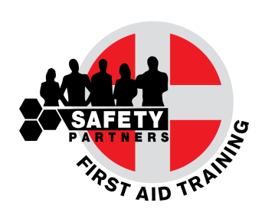

It is Certified that

**CHRISTOS ZENONOS**

has successfully completed the Safety Partners course

**“Basic Life Support & Automated External Defibrillator”**

***Duration: 6 hours***

***12 June 2017***

This certificate is valid for two years

from the date of issue

SPCN: 00776 ______________________

Certificate Number Antonis Siamailas

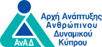 Director

First Aid Scientific Support by Nuco Training UK